Update Paper

Purpose of Report
For information.

Summary
The report outlines issues of interest to the Board not covered under the other items on the agenda.

LGA Plan Theme: Championing climate change and local environments

Recommendation(s)

That the Board note and comment on the update.

Contact details
Contact officer: Mark Norris
Position: Principal Policy Adviser
Phone no: 020 7664 3241
Email: Mark.Norris@local.gov.uk

Update Paper

Background
- This report outlines issues of interest to the Board not covered under the other items on the agenda.
Modern slavery
- The anti-slavery charity Unseen has published its Modern Slavery & Exploitation Helpline data for 2022. Figures show the number of potential victims of modern slavery in the UK more than doubled to record levels last year (6,516 victims, an increase of 116 per cent compared to 2021). There has been a particularly sharp increase in alleged exploitation in the care sector. Potential victims were identified from 99 countries, with Romania being the most common, followed by India, Vietnam, Sri Lanka, Albania, China and the UK.

- We held our second Council Modern Slavery Network meeting in May. The network is an informal meeting of council officers leading on anti-slavery work to share good practice and discuss any issues. Dr Liz Such from Nottingham University presented to the network on taking a public health approach to tackling modern slavery, and Frank Hanson from the Gangmasters and Labour Abuse Authority provided an update on their enforcement activity. Around 65 officers attended the meeting, and there was support for maintaining the network going forward. Our next meeting in September will hear from The Salvation Army, who manage the Modern Slavery Victim Care Contract and are keen to deepen their links with councils, and from Nottingham University on their work on modern slavery in the care sector, an issue that was flagged by a number of councils in May.

- At the previous Board meeting, Board members agreed that they would like to undertake further work to explore the critical factors that have enabled some council’s work on modern slavery to mature more than others, and why some modern slavery partnerships are particularly effective.
- The meeting discussed what evidence there is to substantiate the idea that some areas have made more progress on this issue than others. The former Independent Anti-Slavery Commissioner Dame Sara Thornton has highlighted an October 2020 Nottingham University Rights Lab report on modern slavery partnerships which noted that the are at different stages of development, and that partnership working is frequently seen as a voluntary endeavour, undertaken on top of existing workloads and responsibilities, with individuals and organisations often reluctant to undertake additional responsibilities and commitments.

- Officers have begun developing a short piece of work to look into this issue. It is suggested that in the first instance, this work will engage with council officers, councillors and other individuals/organisations working on modern slavery to seek their perspectives on these issues, before drawing together a short summary report. The report could also highlight good practice case studies from councils, updating the case studies previously produced by the LGA some years ago. Subject to the issues identified, the Board will be able to identify any issues that they would like to follow up in more detail.

- Separately, in 2019 the LGA produced a councillor guide to tackling modern slavery. This highlights the specific role that individual councillors can play in raising awareness of the issue and embedding work to tackle slavery within councils. A related outcome of this work could be to update the councillor guidance in the next Board cycle, following the recent update of our council guide on modern slavery, and to undertake councillor focused awareness raising activity.

- Officers have begun some initial engagement with councils to inform this piece of work and have contacted several members of the LGA’s Council Modern Slavery Network to ask for views. We have also attended a recent modern slavery partnership meeting, chaired by Sandwell Council.

- Subject to approval from the Board, officers will scope out a more detailed engagement and delivery plan for this work, including engaging with the modern slavery champions for their input.
Licensing
- The LGA has submitted evidence to the Welsh Government’s Taxi and Private Hire Vehicle White Paper. Our response highlighted the importance of ensuring there is as much consistency between the English and Welsh taxi/PHV licensing regimes as possible, so that communities who live on either side of the border are still able to access good quality taxi/PHV services and businesses do not face undue challenges from the different frameworks. We called on the Welsh Government to continue to work with the UK Government on this issue.

- We have produced a flyer to promote being on a licensing committee to new members, following feedback from licensing chairs at our leadership essentials course highlighting the difficult in attracting councillors to licensing committees. The flyer highlights that licensing gives members an opportunity to link into different strategic agendas within their council, whilst also providing an opportunity to play a more active role in operational decisions that affect their local area. Officers can download the flyer and add their council’s logo and use it as a tool to encourage members to consider sitting on their licensing committee.

- We have recently published two licensing case studies. The first case study is on Leeds councils’ alcohol licensing data matrix. This details how Leeds’s licensing and public health teams work together to support residents living in areas experiencing high levels of alcohol related harm and alcohol related anti-social behaviour through the licensing process. The second case study highlights how Manchester Council has embedded the principles of Martyn’s Law into their licensing process.

- The Home Office has published the outcome of its consultation on the Late Night Levy. The Government will commence Section 142 of the Policing and Crime Act 2017 which will allow councils to target the levy at specific geographical locations, and will also introduce the option for councils to offer a 30 per cent reduction to late night refreshment providers that qualify for small business rate relief. These are welcome changes that the LGA called for and may increase the uptake of the levy amongst councils (although in practice, we do not envisage widespread uptake as many councils have opted for alternative arrangements, such as Business Improvement Districts).

- In May, there was a House of Lords debate to explore progress on the recommendations made in the Liaison Committee’s report on their post legislative scrutiny of the Licensing Act. The LGA gave both written and oral evidence at this inquiry, and the Committee’s report was published in 2022. During the debate, the Lords continued to express a general view that more needs to be done to integrate licensing and planning, that the agent of change principle hasn’t been adopted to a sufficient extent, and some Lords expressed a view that planning and licensing committees should be merged. Whilst the LGA agrees licensing and planning systems could be better aligned, we strongly disagree that licensing/planning committees should be merged, and it is welcome the Government shares the same view.

- There was also a significant discussion on disability access. The committee recommended that the existing law be amended to require that an application for a premises licence should be accompanied by a disabled access and facilities statement. The Government reiterated their view that the Licensing Act is not the appropriate legislation to address disability access, and said the better framework is the Equality Act which requires businesses to make reasonable adjustments to ensure disabled people can access facilities, a position the LGA has previously agreed with.

- Other issues, such as training of committee members, were also mentioned. The Government highlighted that it is working with the LGA and the Institute of Licensing to encourage more widespread uptake of the training resources available. The Minister also highlighted that they are discussing creating a database of personal alcohol licence holders, and the LGA is involved in these discussions.
Trading standards / vaping
- We have submitted evidence to the Office for Health Improvement and Disparities consultation on youth vaping. Our evidence calls for strict new measures to tackle the sale of vapes to young people, including ensuring vapes are kept behind the counter in plain packaging, and banning free vape samples from being given to children. We also highlighted examples of effective enforcement work being done by trading standards teams from across the country, and called on Government to boost the future pipeline of qualified trading standards officers through a dedicated apprenticeship fund, invest in regional support networks, and enable councils to recover more of the costs of running regulatory services.
New food standards model
- The Food Standards Agency has written to councils confirming that the Food Law Code of Practice has been updated to introduce a new food standards delivery model. The FSA had previously piloted the new model with a number of councils, and consulted on an associated set of changes to the code. The key changes to the model/Code are to introduce a new food standards risk assessment scheme that council officers will use to evaluate the risk posed by a food business and a new decision matrix to determine the frequency at which food standards Official Controls should be delivered in line with the risk assessment, as well as a series of supporting changes. Councils will have until 31 March 2025 to transition to the new model, to allow time for necessary changes to be made to their IT management information systems. LGA officers are engaging with the FSA on these changes, as well as on the new burdens associated with the change.

- Having developed a new model for food standards work (usually delivered by trading standards officers), the FSA is now beginning the process of revising the delivery model for food hygiene work (usually delivered by environmental health teams). Officers will monitor progress on this work as it develops.
Water safety
- The National Water Safety Forum has published its 2022 national drowning fatality report. There were 226 accidental fatalities in the UK in 2022 and almost half were during June, July and August. Inland waters, such as rivers, canals, lakes, reservoirs and quarries, continue to be the leading locations for accidental drowning, with 60 per cent of deaths. Males continue to be over-represented, with 83 per cent of accidental fatalities.
Law Commission work on disposing of the dead
- The Law Commission is currently in the scoping phase for a project titled ‘A Modern Framework for Disposing of the Dead’. The Law Commission states that the legislation governing traditional methods of disposal is “outdated, piecemeal and complex.” The scoping phase will consider what issues they will need to cover in the project and terms of reference will be agreed with the Government. The project will seek to create a future-proof legal framework for the disposal of the dead. It is expected that the project will look at the law around burial, cremation, new methods of disposal, and decision-making following death.
Independent review of Prevent
- Following discussions at the last Board meeting regarding the publication of both the Independent Review of Prevent (which forms part of the government’s counter-terrorism strategy), and the government’s response to it, a letter was sent to the Minister for Security setting out some of the issues raised.

- The letter welcomed the report’s acknowledgement of the importance of councils’ role in Prevent delivery and its emphasis on the wider counter-extremism landscape. It also highlighted concerns about the resourcing implications for councils; of the need to ensure local flexibility is retained in order to respond appropriately to the local threat picture - avoiding approaches that could undermine community cohesion, and which ensure that those who need support or intervention continue to receive it.
Hate crime legislation - sex & gender
- The Government has published its response to recommendation 8 of the Law Commission’s 2021 report on hate crime laws, which accepts the Law Commission’s recommendation that sex or gender should not be added as a protected characteristic for the purposes of aggravated offences and enhanced sentencing.
- The reasons for this include potential difficulties in prosecuting serious crimes which disproportionately affect women and girls, potentially resulting in a two-tier hierarchy of prosecutions, and concerns about particular legal complexities which do not apply in the same way to existing characteristics such as race or religion.

Councillor training on online abuse and misinformation
- The LGA is working with City of London Police to develop a programme of Cyber crime, security and online safety briefings for councillors in the autumn. A scoping session is being planned on 22 June with councillors to ensure the best outcomes for members, and we are seeking councillors to attend who have experience of online abuse, misinformation, and other crime in their role. If you are interested, please indicate your availability through this Microsoft Form.
Community Safety Partnerships review
- The LGA has submitted a response to the Government’s CSP review and consultation on ASB powers, following the publication of the CSP consultation and ASB action plan at the end of March. The response built on feedback from the Board at their meeting in January, and also concerns raised by councils. Many thanks to Board members who submitted feedback on the review.
Anti-Social Behaviour (ASB) action plan: implementation
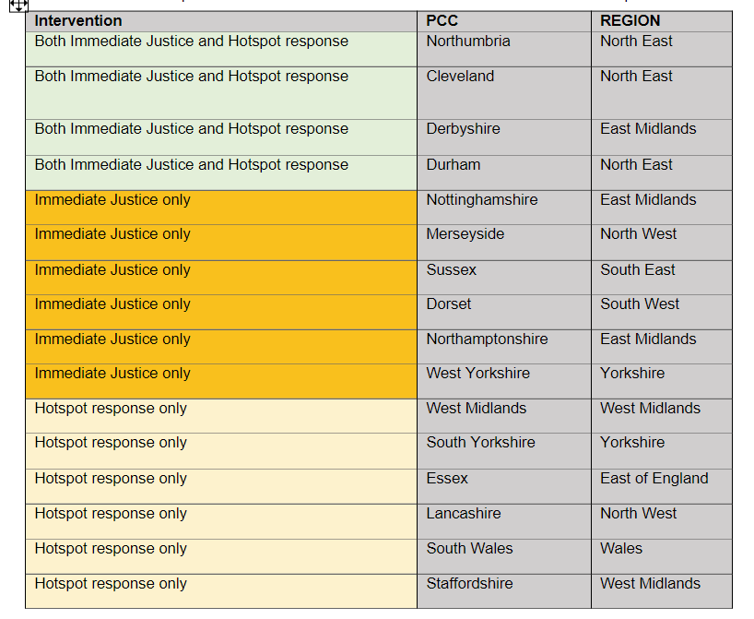
- Officers are engaging with officials from the Home Office and Department for Levelling Up, Housing and Communities regarding the implementation of the ASB action plan. The Government is intending to launch pilots on immediate justice and hotspot policing (which could include the use of additional uniformed LA officer capacity) this summer, with pilot areas already identified (see below). Dedicated funding will be available to support the pilots – this will be distributed to PCCs with an expectation that plans will be discussed with local authorities.

- The LGA is supporting the Government in identifying officers who can support in the development of mandatory reporting metrics on ASB. We have also emphasised our willingness to convene groups of local authorities from the pilot areas to provide local government input on the pilot approaches, as well as wider groups of councils on other issues.

- The LGA is again supporting ASB week, which this year takes place from 3-9 July. The week is coordinated by Resolve, and supported by the LGA, APCC, NPCC and others. ASB week has a different focus each day, which this year will feature:
- Monday: ASB Case review (formerly known as the community trigger) relaunch
- Tuesday: Victims’ day
- Wednesday: The Big ASB Conversation
- Thursday: ASB Heroes Day
- Friday: Young People’s Day
- Saturday: ASB and health
- Sunday: Community Action Day
- The LGA is encouraging member councils to support ASB week with local activity and social media promotion. Further information and media resources are available on the Resolve website.
Victims and Prisoners Bill
- The draft Victims and Prisoners Bill was published at the end of March. As expected, it includes provisions that will require tier one councils (unitaries, counties and the GLA), Police and Crime Commissioners (PCCs) and health bodies to collaborate when commissioning services for victims of serious violence, sexual violence and domestic abuse. The LGA briefed Parliament on second reading of the Bill in May, raising concerns about the potential duplication between this provision, the recent serious violence duty and the accommodation based support duty in the Domestic Abuse Act, and emphasising the need for adequate funding for victim support services. In discussions with the Ministry of Justice, we have been emphasising the need for local areas to be able to take a flexible approach to developing a local commissioning approach that complements rather than duplicates existing structures.
Offensive weapons homicide reviews (OWHRs)
- Officers have attended the offensive weapon homicide review pilot board, set up to oversee the pilot of OWHRs in three areas – the West Midlands (Birmingham and Coventry), London (Lambeth and Southwark) and South Wales. The pilot launched on 1 April and will last eighteen months, with an independent evaluation running alongside it. OWHRs were established under the Police, Crime, Sentencing and Courts Act and associated regulations, and can take place following the death of a person aged 18 or over involving the use of an offensive weapon. The police, local authorities and Integrated Care Boards are required to review the death to identify any lessons learnt and whether any action should be taken as a result.
Nitrous oxide consultation
- Following the publication of the Anti-Social Behaviour Action Plan in March, the Government is consulting on the planned ban on the sale of nitrous oxide, commonly referred to as laughing gas. The consultation sought views from suppliers and retailers about exemptions for legitimate uses. It is possible that enforcement of a future ban may rest with trading standards teams, so the LGA will monitor the outcome of the consultation and discuss any implications for councils.
Sex for rent consultation
- The Government is also consulting on the exchange of sexual relations for accommodation, commonly referred to as sex for rent consultation. The consultation seeks views on how widespread this practise is, and how the response to it could be strengthened. Although we believe any new measures in this space may be more likely to effect local authority private sector housing teams, we will continue to monitor the outcome of the consultation and the implications for councils.

Implications for Wales

- Officers to work with the Welsh LGA as necessary.

Financial Implications
- None.

Equalities implications
- To be considered in relation to each individual policy area.

Next steps
- Officers to continue progressing these issues as required.

